Kevin Chung

Period 5

3/2/20 - 3/6/20

Journal 21

Our project finally works! This week, Kevin Fu and I worked out bugs that we were having with piece detection and trained a new model with a new dataset. Previously, we were just using a rectangle slice from the raw image that approximated how high a piece was, but it didn’t field very good results. Instead, we took a parallelogram slice of the image, which takes perspective into account. We then “unshear” the parallelogram to a rectangle and resize it before feeding it to the piece classification network.

However, all of our training data for piece classification was taken from the same setup. Kevin Fu is currently working on training the network with data from several angles, and hopefully it has the same success as this network does. Below are two example images:

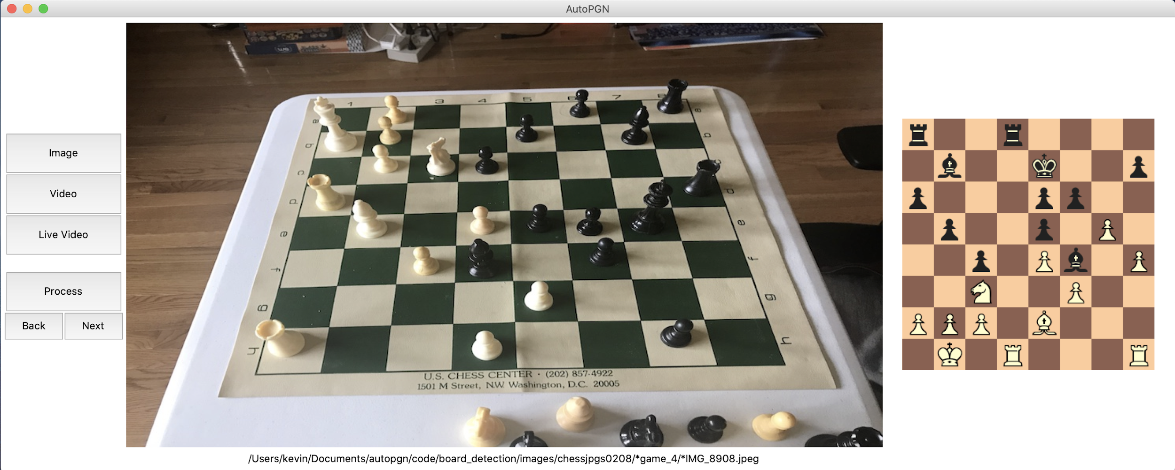

In the above image, the network got every piece correct. I tested out several images yesterday, and I found that it only classified one piece wrong out of about twenty images, which is much better than we had before. The most common mix ups are with pawns. Sometimes the CNN will classify a pawn as the wrong color, mix it up with a bishop, or say that there is no pawn at all.

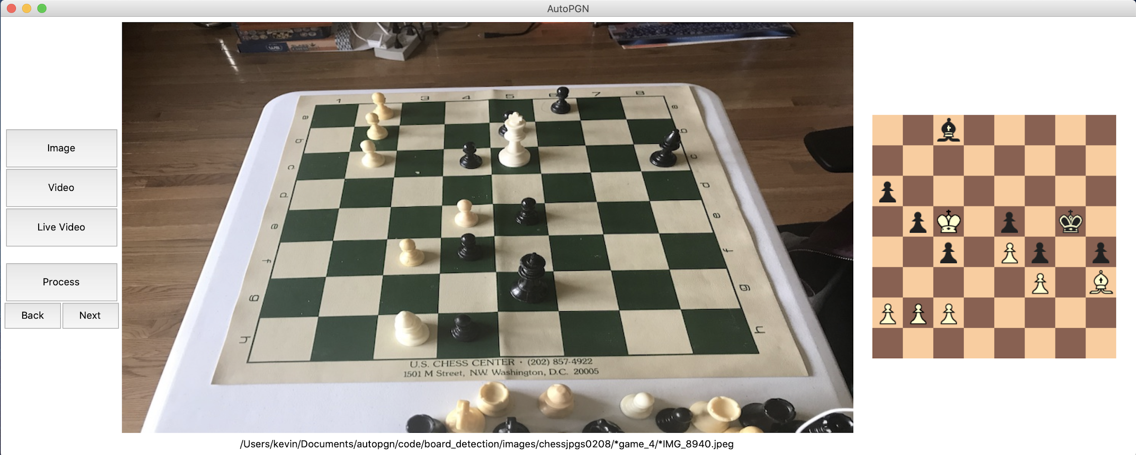

I was particularly surprised by this image. On b5, there is a black pawn that is very obscured by a white king in front of it. Yet somehow the network classified it correctly. One reason could be that we trained the classification network on some examples with obscured pieces, so it is familiar with these cases.